## Movie Catalogue User Guide

**Introduction**

This document describes BDD cucumber framework which contains movie catalogue application automation test scripts through Appium-Java. It explains the operational details.

**Automation Framework Architecture:**

The Framework consists of the following components

1. **src/main/java**

It consists of packages containing all framework specific utility files

1. **src/main/resources**

It consists of framework user guide, selenium grid files and odbc jar

**3 src/test/java**

It consists of packages containing all test utility files, page object files and test scripts

1. **src/test/resources**

It consists of log files, TestData.xlsx, downloaded files from application

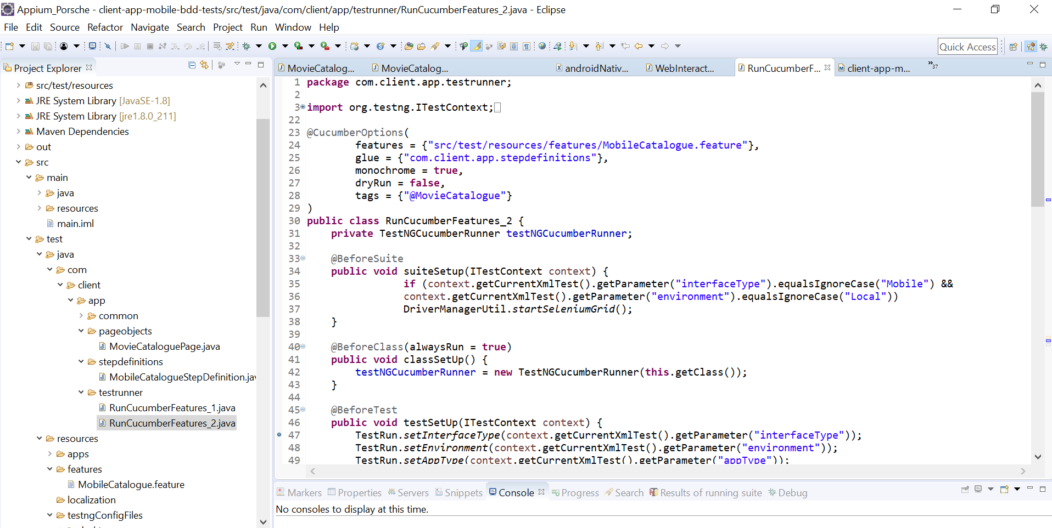

**Movie Catalogue Use case:**

Selected app : <https://github.com/IhwanID/belajar-android-jetpack-pro.git>

1. going from main movies list screen to the details screen of the app
2. based on the screens in the app write Cucumber features

**Java classes:**

1. MovieCatalogueUtil (utility file)
2. MovieCataloguePage (page objects)
3. MobileCatalogueStepDefinition (steps of tests)
4. RunCucumberFeatures_2 (Main method)
5. MobileCatalogue (feature file)
6. androidNative.xml (XML for dependencies)

**Steps:**

1. Clone the git project in Android Studio

<https://github.com/IhwanID/belajar-android-jetpack-pro.git>

1. Generate APK and install in application
2. Login in TMDB portal to get test data
3. Create MobileCatalogue (feature file) with steps to test with examples
4. Create MovieCatalogueUtil file for reusable code
5. MobileCatalogueStepDefinition file will contain all steps for performing action
6. RunCucumberFeatures_2 file containing @test method for invoking and running the script
7. Androidnative.xml file will contain all desire capabilities for test and run

**Executing Test Suite**

1. Click on Maven pom.xml and update the suiteXmlFiles to relevant TestNG config file name. e.g. ‘androidNative.xml’

OR

1. Run androidNative.xml’ as testNG.Suite for test

**Reports**

1. Go to src/target/surefire-reports/Mobile Test Suite/Mobile Catalogue Test.html report

It contains screenshots of all pages.

